FLEXIBLE METAL HOSE AND CONNECTORS

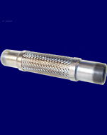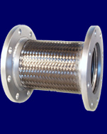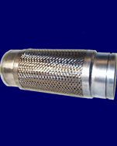

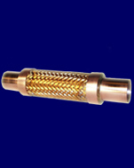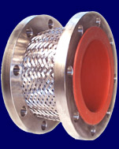

Metal Hose and Connectors are an important part of a wide range of systems that require flexibility in fluid transfer to reduce system noise, isolate vibration and allow for alignment compensation.

A complete line of braided metal hose, metal expansion joints, flexible connectors, and Teflon lined metal hose are available in many different sizes, materials and end configurations; flanged, threaded, weld, tri-clamp, etc.

Also available at Stemmerich are PTFE and rubber expansion joints.
Stemmerich, Inc.
4728 Gravois Avenue · St. Louis, MO. 63116
800-325-9528 · Fax 314-832-7799 · www.stemmerich.com
Branch Offices: Kansas City, KS

